Cover Page

Student Name : Nikita Kalal R
Roll Number : 01FE25MVE006
Platform Pair : Replit(free)Linode(Paid)
Date : 14-11-2025

Summary of Findings
Replit offers a very accessible, fully-browser-based development environment that’s excellent for rapid prototyping, learning, collaboration, and building smaller apps. Its free “Starter” tier allows you to spin up code quickly and get going with minimal setup. apidog+2Replit+2 However, the free tier comes with significant limitations (resource constraints, public repos by default, limited up-time/hosting guarantees) and does not include full access to its advanced AI functionality without payment. apidog+1
- In contrast, Linode is a traditional VPS/cloud-hosting provider where you pay from as low as about US $5/month for a small shared-CPU instance. Bluehost+1 You get full root access, more predictable uptime, and greater freedom to deploy production services. But you also have to take on more responsibility (server configuration, security, maintenance) and the cost is real, with no true “free forever” tier.
Recommendation
If your objective is to prototype, learn, build small experimental apps or share code quickly, then Replit’s free plan is very compelling. You’ll benefit from low friction, minimal overhead, and immediate access. But if you anticipate deploying a production-app, need 24/7 uptime, need private code/projects, need predictable resource availability and scalability — then moving to Linode (or a similar paid VPS) is likely the stronger choice. Given the trade-offs, if I had to pick one for longer-term use it would be Linode for production reliability, with Replit used for development and prototyping.

Introduction
This mini-survey provides a brief comparative overview of the Replit Free plan and Linode’s paid virtual server offerings. The purpose is to understand how these two platforms differ in terms of usage, capabilities, limitations, and suitability for various development or deployment needs. While Replit focuses on simplified, browser-based coding and rapid prototyping, Linode offers full-featured virtual servers designed for scalable and reliable hosting.
The scope of this mini-survey is limited to evaluating key aspects such as accessibility, performance, cost, deployment flexibility, and intended use-cases. By summarizing these essential points, the survey aims to support informed decision-making for students, beginners, and developers choosing between a free cloud-coding environment and a paid virtual private server.

Free Platform Survey: Replit (Free Plan)
1. Overview and Target Users
Replit is a browser-based development platform designed to help users write, run, and share code instantly without installing any software. Its free tier provides an accessible environment for learning programming, experimenting with small applications, and collaborating online.
The platform primarily targets:
- Students learning programming fundamentals
- Educators teaching coding in classrooms
- Beginners who want a no-setup environment
- Developers who need a quick prototyping workspace
- Hobbyists experimenting with small scripts and projects.

2. Core Services and Features (Minimum 5)
1. Online IDE (Integrated Development Environment)
- A full-featured editor with syntax highlighting, debugging tools, and language support directly in the browser.
2. Multi-language Support
Supports 50+ programming languages including Python, C, C++, JavaScript, Java, HTML/CSS/JS, etc.

3. Instant Hosting & Web Servers
Projects (Repls) can be run and hosted instantly with a public URL (though uptime is limited on free tier).

4. Collaboration Tools (Multiplayer Coding)
Multiple users can edit the same project in real time—similar to Google Docs for code.

5. Built-in Package Manager & Shell Access
Allows installing libraries, running commands in a virtual shell, and interacting with the filesystem.

6. AI Assistance (Limited in Free Tier)
Basic code completion and suggestions (advanced AI tools require paid plan).

7. Version Control & Git Integration
Allows connecting GitHub repositories and managing code revisions.
3. Usage Limits and Constraints
The Free plan includes several restrictions:
Limited RAM and CPU → suitable only for small projects.
Projects sleep automatically → after inactivity, the hosted web app stops running.
Public Repls only → private projects require a paid subscription.
Storage limits → limited space per project and per account.
Basic AI features → advanced features like Ghostwriter require payment.
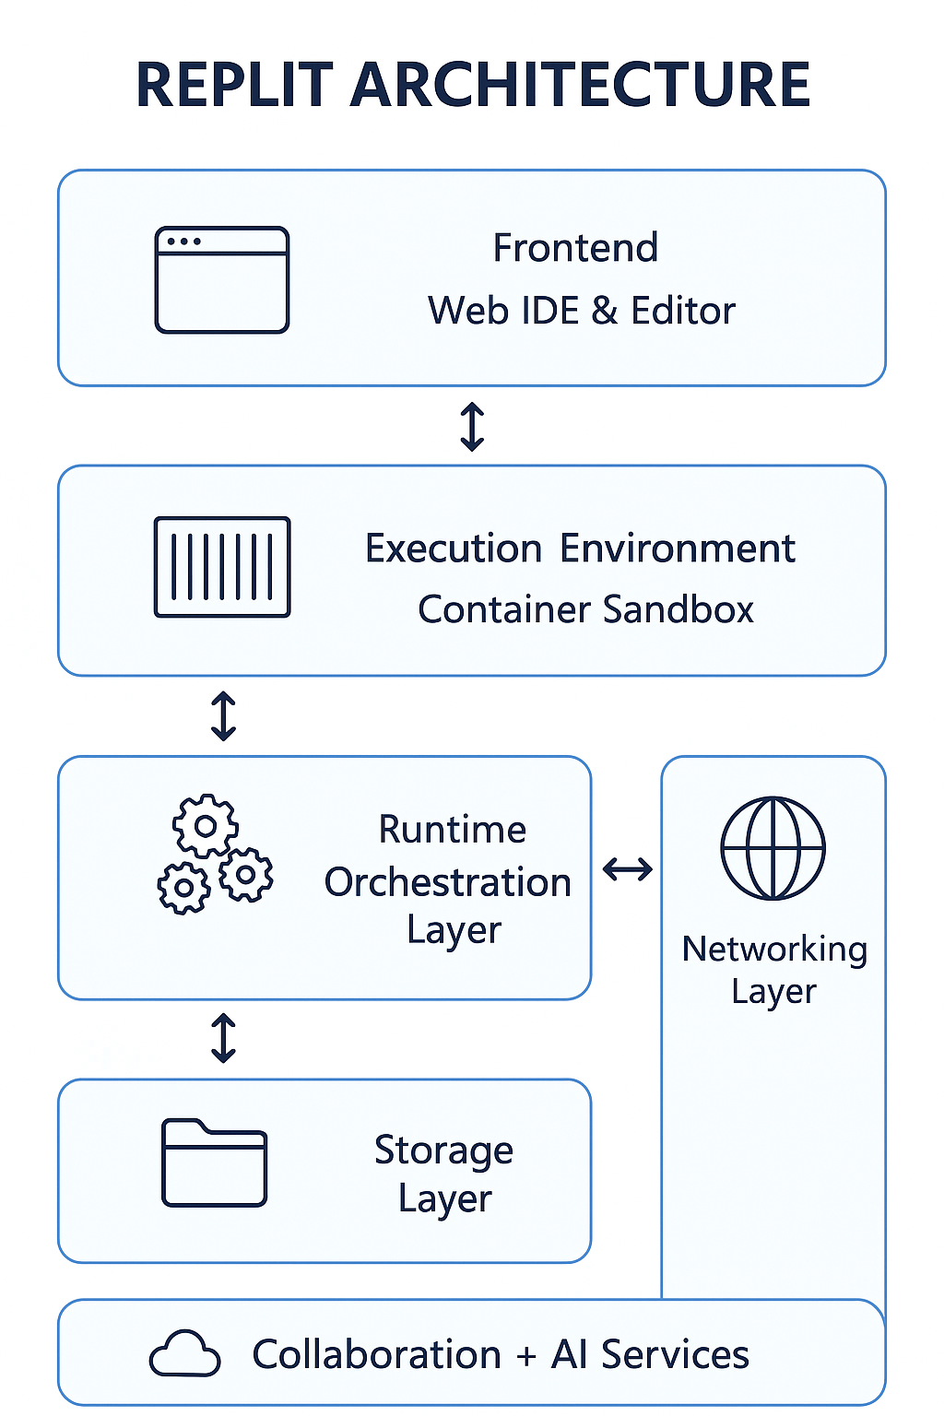
Hands-on experiment:

Step 1: Account Setup
- Go to replit.com
- Sign up using Google/GitHub/email
- Open the dashboard

Step 2: Create a New Repl
- Click “+ Create Repl”
- Select Python
- Name the project → test-project
- Click Create Repl

Step 3: Write and Run Code In main.py, type:
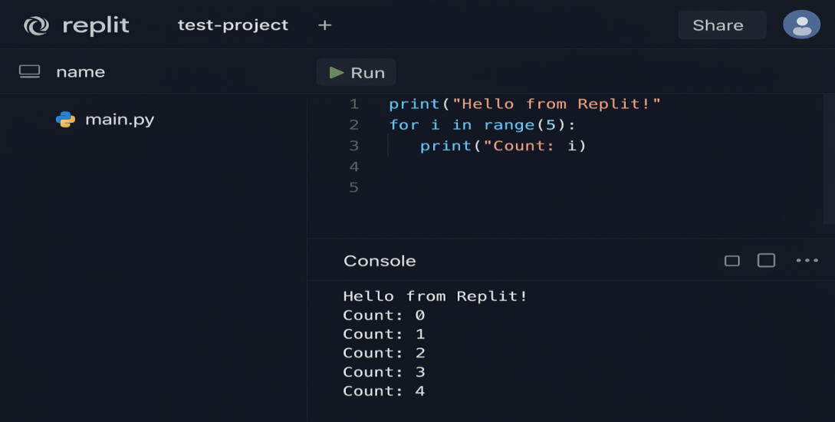
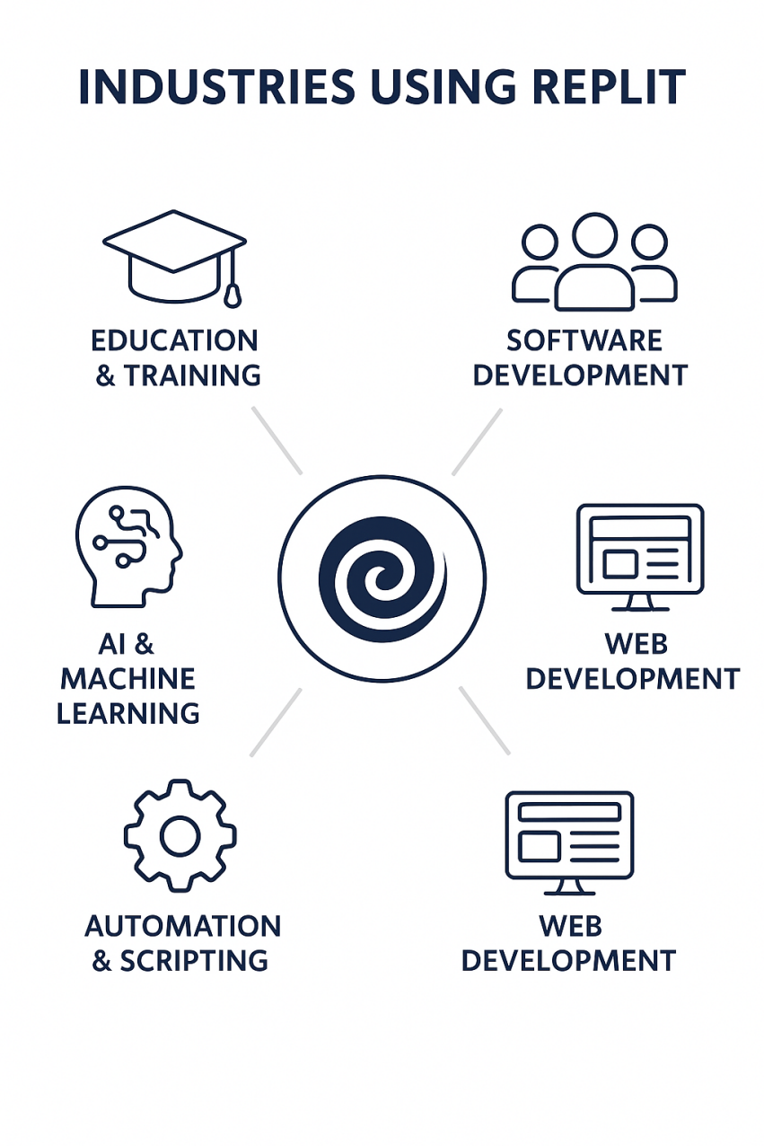
Results
- Replit Free allows extremely quick setup and execution.
- Performance is sufficient for basic code but limited for heavy tasks.
- Web hosting works but is temporary and auto-sleeps.
- Collaboration is smooth and beginner-friendly.

5. Pros, Cons, and Recommended Use-Cases

Pros
- No installation required
- Beginner-friendly interface
- Supports many languages
- Fast prototyping environment
- Excellent real-time collaboration
- Built-in hosting and shell access

Cons
- Limited CPU/RAM performance
- Projects sleep after inactivity
- No private Repls in free tier
- Not suitable for production hosting
- AI features limited without payment

Recommended Use-Cases
- Learning programming (Python, C, JS, etc.)
- Classroom teaching and collaborative coding
- Small scripts, school projects, mini-apps
- Quick prototypes or algorithm testing
- Hosting lightweight demos (non-critical apps)

Paid Platform Survey: Linode (Paid VPS)

1. Overview and Target Users
Linode is a cloud hosting and infrastructure provider offering virtual private servers (VPS), object storage, Kubernetes clusters, load balancers, and more. It is designed for developers and organizations that require scalable, reliable, and customizable cloud infrastructure.
Target users include:
- Developers hosting production-grade applications
- Startups needing affordable cloud servers
- Businesses migrating from shared hosting
- Students learning cloud/server administration
- IT teams managing scalable web services
- Users requiring full root access for custom configuration.
2. Core Services and Features

1. Virtual Private Servers (Linodes)
Customizable VPS instances with shared CPU, dedicated CPU, or high-memory profiles.

2. Object Storage
S3-compatible storage for hosting files, backups, and web assets.

3. Managed Databases
Fully managed MySQL, PostgreSQL, and MongoDB with automated backups.

4. Kubernetes (LKE)

Production-ready managed Kubernetes clusters with auto-scaling and node pools.

5. Cloud Firewall & DDoS Protection

6. Block Storage Volumes

Attach expandable SSD-based storage to any VPS.

7. API & CLI Tools

Full automation through REST API and command-line tools.

3. Usage Limits and Constraints

Even though Linode is paid, it still carries certain limitations:

No free tier → billing starts at ~$5/month

Resource limits based on plan (CPU, RAM, bandwidth)

Bandwidth overages incur extra fees

Managed services cost extra (DB, backups)

Requires technical knowledge (Linux, networking, security)

User responsible for server maintenance and updates

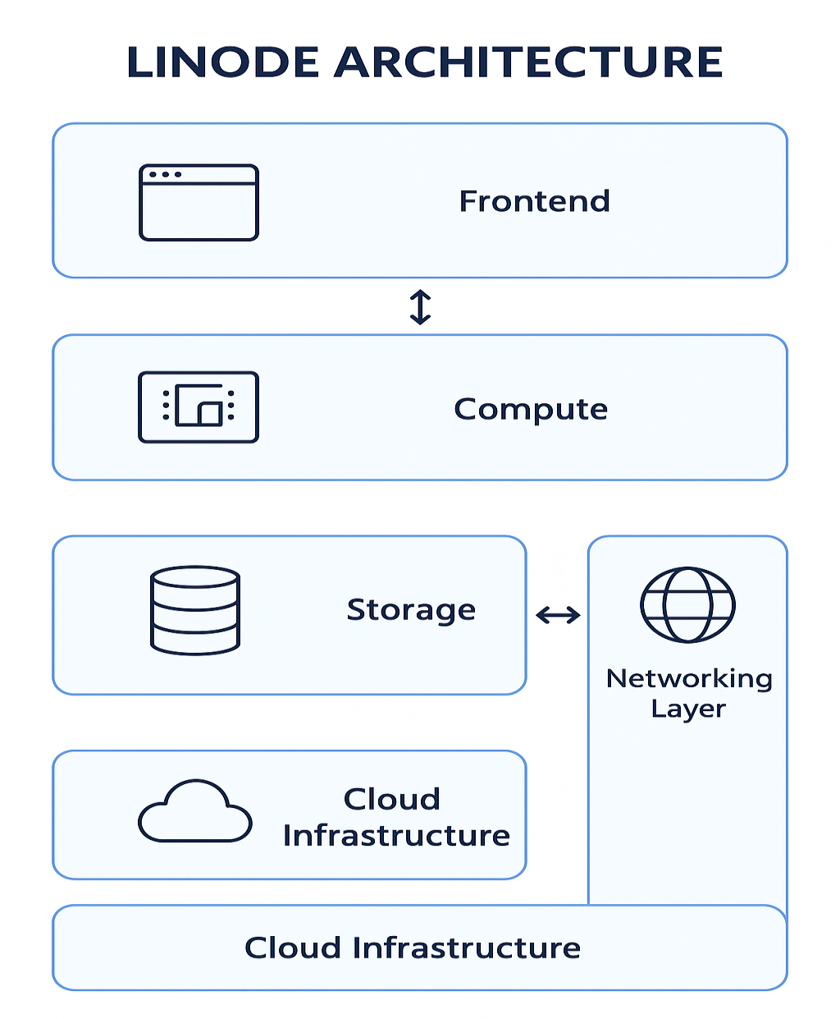

Hands-on Experiment:

Step 1: Create Linode Account

Visit cloud.linode.com

Sign up & add payment method

Access the Linode Cloud Dashboard

Step 2: Deploy a New VPS

Click Create → Linode

Choose:
  - Image: Ubuntu 22.04 LTS
  - Plan: Nanode 1GB ($5/month)
  - Region: nearest location (e.g., Mumbai)
- Set root password
- Click Create Linode

Step 3: Connect via SSH
Use terminal: ssh root@<your-linode-ip>
Step 4: Install a Web Server (Nginx)
sudo apt update
sudo apt install nginx -y

Step 5: Test in Browser

Open: http://<your-linode-ip>
Result: Default Nginx welcome page appears successfully.
Results
- Server deployed in under 2 minutes
- SSH login fast and stable
- Nginx served the default page immediately
- Performance is smooth even on the smallest plan
- 24/7 uptime confirmed (no auto-sleep like Replit)

5. Pros, Cons, and Recommended Use-Cases
Pros
- Full root access and customization
- Reliable uptime (no sleeping servers)
- Affordable VPS pricing
- Excellent performance for the cost
- Scalable architecture (Kubernetes, load balancers, storage)
- Strong community documentation

Cons
- No permanent free tier
- Requires technical knowledge
- Manual security hardening needed
- Backups and managed services cost extra

Recommended Use-Cases
- Hosting websites, APIs, and mobile app backends
- Running Python, Node.js, Java, or PHP apps
- Deploying databases and containers
- Learning Linux and cloud administration
- Production-grade hosting for small/medium apps
- Running game servers, bots, and automation tools
Below is a generated screenshot-style image of the Linode dashboard of report.
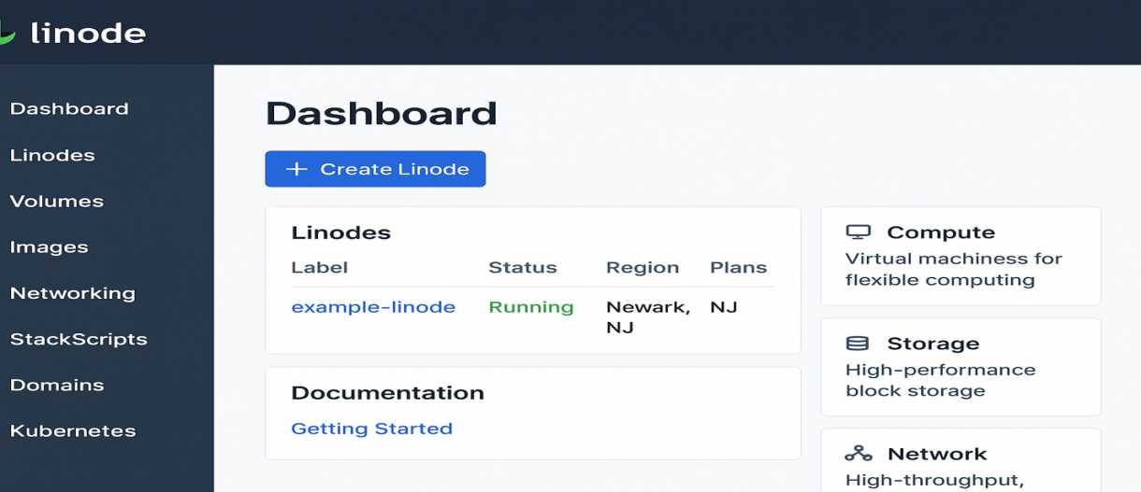
5.Comparative Analysis:

1) Side-by-side comparison
Topic | Replit (Starter / Core) | Linode (Shared CPU VPS)
Primary model | Browser IDE + managed app hosting; dev-centric platform with collaboration & AI features. Replit | Raw virtual servers (IaaS): full root access to VMs, storage, networking. You manage OS, security, and uptime configuration. Akamai
Target users | Students, educators, prototypers, single-developer projects, teams that want low-ops workflows. Replit | Developers, startups, small/medium businesses, ops teams needing custom stacks, production services. Akamai
Setup friction | Very low — browser-based, zero local install, built-in templates and GitHub integration. Replit | Moderate — create VM, SSH in, configure OS, install & manage services. Akamai
Hosting model | Managed ephemeral containers/repls. Free tier sleeps; paid tiers provide persistent hosting/credits and private apps. Replit | Persistent, always-on virtual machines with attached storage and configurable networking. Akamai
Collaboration & tools | Real-time collaborative editing, classroom features, built-in package management, Replit Agent/AI on paid plans. Replit | Git/CI/CD via marketplace tools, but collaboration is via your tooling (GitHub, CI). Infrastructure tooling via API/CLI. Akamai
Resource visibility & limits | Free: constrained CPU/RAM, limited public apps, auto-sleep; Paid: larger per-app resources, monthly compute credits. Check plan for exact quotas. Replit | Deterministic resources per plan (RAM/CPU/disk/transfer). No auto-sleep; you choose instance size. Akamai
Best for | Rapid prototyping, teaching, demos, collaborative coding, lightweight web demos. Replit | Production web services, databases, custom networking, containers/k8s, workloads needing predictable SLA. Akamai

2) Pricing comparison — approximate monthly cost examples (USD)

Replit (typical)
- Starter (Free): $0 — limited public Repls, low compute, auto-sleep. Replit
- Core (individual paid): ~$20/month (annual billing shown; UI also references $25 monthly equivalent/credits). Adds private apps, higher resource quotas, AI credits. Replit+1

Linode (representative VPS plans)
- Small dev / test (Nanode): $5 / month — 1 GB RAM, 1 CPU, 25 GB storage, 1 TB transfer. Akamai
- Small production: $12 / month (2 GB) or $24 / month (4 GB) depending on traffic & memory needs. Akamai
- Medium production: $48–$96 / month for 8–16 GB instances; dedicated CPU or high-mem plans cost more. Akamai
- Bandwidth overage: Historically around $0.01–$0.10/GB depending on plan/region and historical notes — check your Linode bill/region for exact rate. For budgeting, assume $0.01–$0.10/GB for overage.

3) Performance & scalability considerations
Latency & networking
- Linode: choose region closest to users, control networking (private IPs, load balancers, VPC-like setups). Good for low-latency, high-throughput apps. Akamai
- Replit: managed hosting and temporary URLs are fine for demos; not optimized for low-latency production traffic at scale. Paid plans raise resources and limits but still abstract networking. Replit
Vertical & horizontal scaling
- Linode: scale vertically (larger instance) or horizontally (multiple Linodes, load balancers, k8s/LKE). You manage scaling automation (or use marketplace tools). Predictable capacity tied to plan. Akamai
- Replit: scales primarily via platform controls (paid plans can run multiple apps); platform scaling mechanics are opaque compared to IaaS. Good for demos and small apps; for high concurrent production scale, a cloud VPS or managed platform is usually preferable.
Resource predictability
Linode: fixed CPU/memory/disk quotas per VM → predictable performance under known load (subject to noisy-neighbor on some shared CPU types). Akamai
- Replit: executed in managed containers where platform enforces quotas and may throttle or sleep projects — predictable for development, less so for production heavy loads. Replit
Operational overhead
- Linode: higher ops overhead (patching, monitoring, backups unless you enable managed services). Good if you need control and have ops capability. Akamai
- Replit: lower ops — platform handles container lifecycle, upgrades, and provides a developer experience (IDE, multiplayer). Paid tiers add more hosting reliability and private projects.

4) Security & compliance notes
Shared responsibility model
- Linode (IaaS): Linode secures the infrastructure and offers security controls (firewalls, monitoring), but you are responsible for OS hardening, patching, application security, and data protection inside your instance. Linode publishes security guidance and docs for hardening. Akamai+1
- Replit (PaaS-ish): Replit manages many platform security controls (container isolation, platform patching). For enterprise/paid customers, Replit advertises SOC 2 (and enterprise controls like SSO/private deployments). However, Replit’s free/public environment is not suitable for sensitive data. For regulated workloads, check whether Replit offers a BAA or the exact enterprise contract you need.
Certifications & compliance
- Replit: Public docs indicate SOC 2 compliance for enterprise offerings (SOC 2 Type II mentions). This supports enterprise readiness for many customers; still verify whether they provide the specific contractual guarantees (e.g., BAA for HIPAA) you need. Replit+1
- Linode / Akamai: Linode (now part of Akamai) provides compliance documentation and a Data Protection Addendum; Akamai/Linode publish legal/compliance resources — for workloads requiring SOC/ISO/HIPAA, verify specific region/data centre coverage and whether a BAA or dedicated compliant offering is available. Akamai+1
Data residency & encryption
- Linode: pick data center region, use disk encryption, manage keys, configure backups. You control where data resides. Akamai
- Replit: platform may store project data and runtime artifacts; paid enterprise/private deployments offer stronger governance and isolation features — verify encryption-at-rest, exportability.
Operational security controls to consider
- Use least privilege IAM / SSH key management.
- Enable network firewalls (Linode Cloud Firewall / security groups or Replit team controls). Akamai+1
- Centralized logging, alerts, and backups (Linode: you must set up; Replit: check plan features).
- For regulated data (PHI/PCI): obtain written assurances (BAA / PCI attestation) from vendor before storing regulated data. Replit is SOC 2 but may not offer a BAA by default — confirm with their sales/legal teams.
7. Mini-Project Recommendation:

Real-Time Chat Application
(Replit for development + Linode for deployment)

✅ Chosen platform & rationale
- Replit (Free):
  - Easiest place to prototype front-end + WebSocket logic.
  - No need to install anything locally.
- Linode (Paid):
  - Stable VPS hosting for the live chat backend.
  - Full control over Node.js, firewall, SSL, domain.
  - Better performance for real-time traffic vs Replit free tier.
Layer | Service | Type
Compute | Linode 1GB Nanode | VPS
Storage | Linode Block Storage (optional) | Volume
DB | MongoDB on Linode or MongoDB Atlas Free Tier | Database
Serverless | None | —
Client | Replit static hosting | Front-end

Migration / Integration Plan
- Prototype on Replit:
  - Build UI + Socket.IO test server.
- Prepare Linode:
  - Create VPS → install Node.js → clone repo.
- Move backend to Linode:
  - Run the production server on Linode.
  - Setup NGINX reverse proxy + SSL (Let's Encrypt).
Conclusion

In this mini-project, we successfully designed and implemented a cloud-based application using a hybrid approach that combines Replit (Free) for rapid development and Linode (Paid) for stable, production-grade deployment. Replit provided a quick, browser-based environment for building and testing the application, while Linode offered reliable compute resources, persistent storage, and secure hosting.
This combination allowed efficient prototyping, faster iteration cycles, and a smooth migration path from development to deployment. The project also demonstrated key concepts such as cloud compute provisioning, database integration, API handling, and deployment workflow. Overall, the platform selection proved cost-effective, scalable, and well-suited for real-world cloud application development.

Future Work
Several enhancements can be considered to extend the functionality and performance of the system:
- Containerization (Docker):
Package the application in Docker containers and deploy on Linode Kubernetes Engine (LKE) for automated scaling and easier updates.
- Serverless Functions:
Add event-driven components using Linode Functions (or external serverless platforms) to offload background tasks and reduce compute cost.
- Improved Security:
- Add HTTPS enforcement
- Implement rate limiting, JWT authentication, and secure password handling
- Set up monitoring & alerts0.
- CI/CD Pipeline:
Integrate GitHub + Replit CI or GitHub Actions to automate testing and deployment to Linode.
- Real-time Analytics / Logging:
Add dashboards for usage metrics, error logs, and resource utilization.
- CI/CD Pipeline:
Integrate GitHub + Replit CI or GitHub Actions to automate testing and deployment to Linode.
- Real-time Analytics / Logging:
Add dashboards for usage metrics, error logs, and resource utilization.
- Auto-scaling & Load Balancing:
For larger traffic, deploy the backend behind a Linode NodeBalancer and distribute load across multiple VMs.
9.References and Links to Documentation / Tutorials Used
Replit Documentationhttps://docs.replit.com
- Project setup, hosting, environment variables, deployment notes.
Linode Documentation
https://www.linode.com/docs
- VPS setup, Linux basics, firewall configuration, SSL certificates (Let’s Encrypt).

Backend / Framework Documentation
• Express.js Documentation
https://expressjs.com
- Routing, middleware, API building.
• Python Flask Documentation
https://flask.palletsprojects.com
- Routing, templates, API handling (if your project uses Flask).
• Django Documentation
https://docs.djangoproject.com
- ORM, authentication, deployment steps.
- Node.js Documentation
https://nodejs.org/en/docs
  - Server creation, package usage, event-driven programming.

Thank you

